Ibrahim Adam & Daniel England

PLANNING document

Table of Contents

Why we chose this idea? 2

The MVP (Minimum Viable Product) 2

Choice of data 2

Data review 2

Sketches 3

# Why we chose this idea?

For this project, we decided to pitch for the Twitter stream idea. This was an idea which we felt would be ideal to display data from Twitter in an appropriate manner. The data that we intend to use from Twitter can be converted in different formats making it easy for people to read and understand. A large amount of plain text can be difficult to read and interpret especially if the displayed data has a purpose.

Due to this, we felt that we can display data from Twitter in a suitable manner which would make it easier for users to understand. This idea also allowed us to be flexible with how we display this data. Whether we display it using charts, scales or any other way; it was up to us how we decide to display the data.

Depending on the data we decide to use and display, we would like to portray the emotional side of the dataset. The data that will be displayed will show how success it is on Twitter. This will be measured by how many tweets there are in a period of time, the amount of likes and retweets and other interaction. As users will read the data displayed in our chosen ways, they should easily get a sense of understanding as to how successful the subject of the dataset is.

# The MVP (Minimum Viable Product)

The MVP of this project is to successfully display a set of data on a canvas in such a way which makes it easy for users to read and understand the data. The audience will also be able to gain an insight as to how successful the dataset it when displayed.

# Choice of data

Our first idea was to choose a person and then analyse their tweets. It soon became clear though that choosing a hashtag would give us far more robust results so that was the direction that we have gone in. Using an account can yield interesting results as it allows you to analyse a person and find out interesting information about them such as their location or what hashtags they use most. A hashtag though, allows you to look at a near limitless amount of people and then really dig into what context they are using the hashtag in and why it is being used more at certain times.

# Data review

The data that we have chosen to analyse is that of the hashtag #football. Our reasoning behind using #football is because of it’s immense popularity. This level of popularity is one that will never wane, as there will always be people discussing football in some capacity. This means that the pool of data which we can pull from is incredibly large and will allow us to do some interesting things with the data. We will be using a line graph to show the frequency of tweets that use the hashtag, this will be updated in real time. There will also be a selection of recent tweets which will be displayed in order to show off what is being talked about in football at this very moment. The third way we will be displaying this data is through the use of a pie chart which will show off the tweet interaction.

# Sketches

Before deciding how to layout the chosen data, we sketched a few ideas and built the one which we felt was more effective and suitable than the others.

The sketch that we choose to build and the charts we use may change when it comes to the actual build as we will have a better idea how the dashboard looks when creating it.

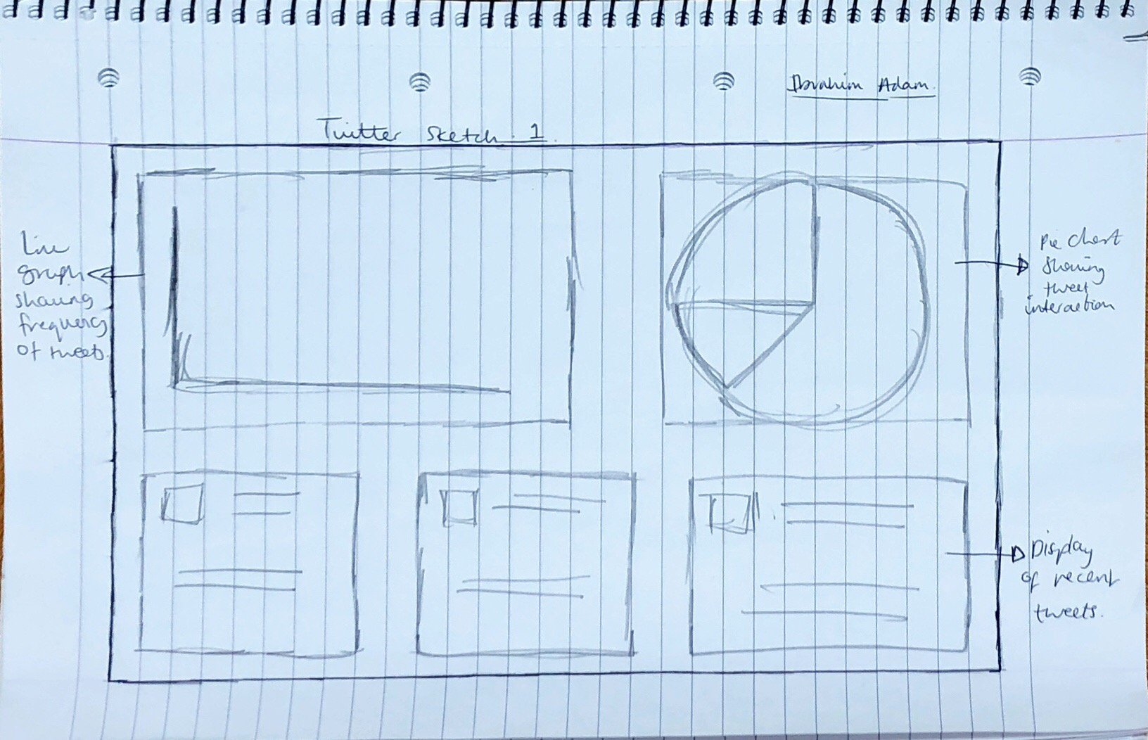**Sketch 1**

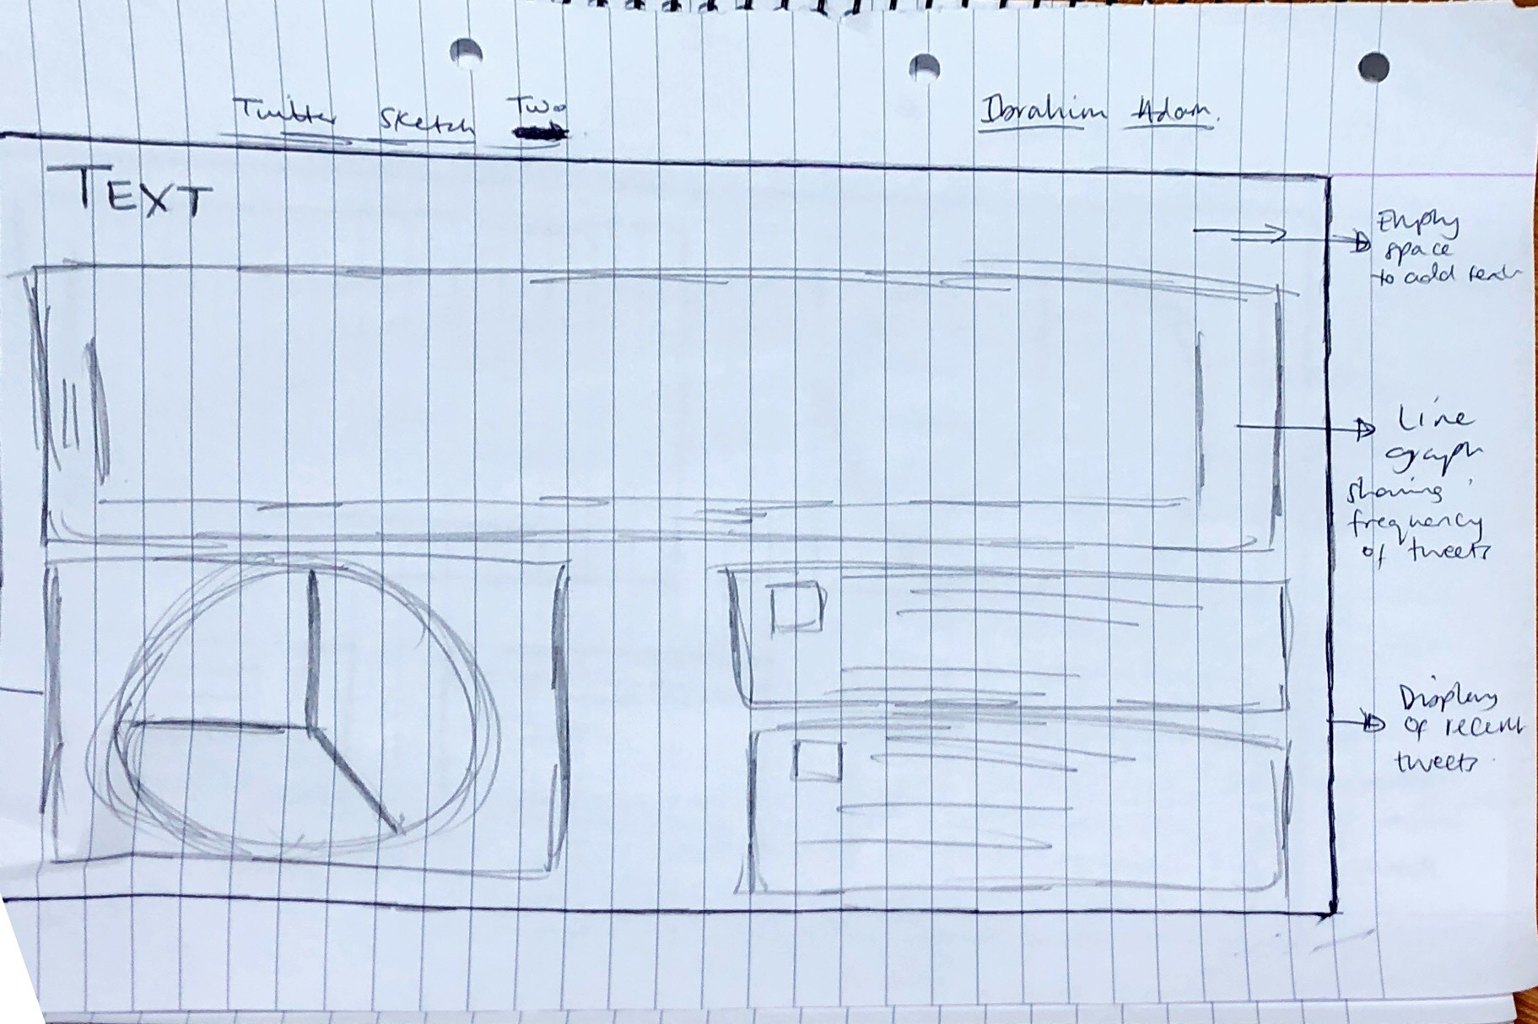**Sketch 2**

We have decided to build the content based on the layout shown in sketch 2.